1. **Figures and Tables**

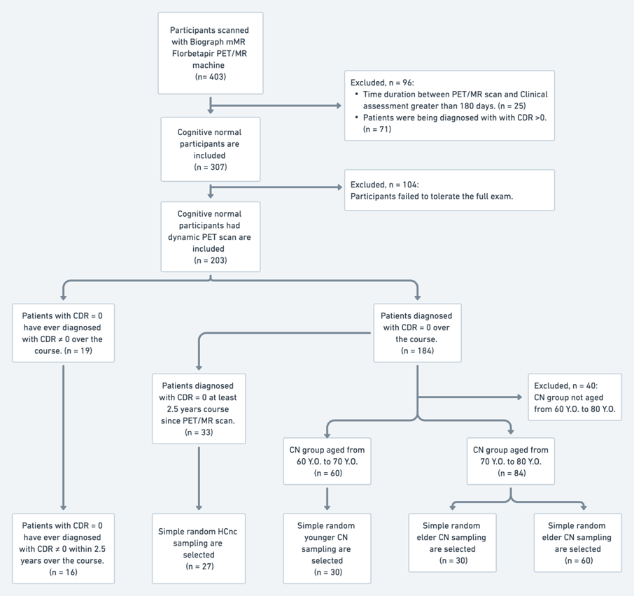

**Fig. 1** Flow chart of the participants' selection

**Fig. 2** Correlation plots of six DOFs between coregistration parameters and GT parameters. The left panel shows the correlation between FSMC parameters and GT parameters. The right panel shows the correlation between TCBC parameters and GT parameters.

**Fig. 3** ComparingWM ROI fusion images before and after coregistration in the typical example subject. WM (black contour) is derived from FreeSurfer volumetric parcellation. The left column is the same axial slices without correction and with the FSMC and TCBC correction. The right column is the zoom-in from the cyan square in the left column. The fusion images showed better overlay on the higher AV45 uptake pixels after the coregistration.



**Fig. 4** The fusiform SUVR value in yHC (n = 30) and eHC (n = 30) before and after four coregistration methods. The uncorrected SUVR shows no significant difference. With the FSMC, there is a significant difference under the 0.05 level. In TCBC, FSMC + TCBC, and TCBC + FSMC, the mean SUVR in eHC shows a significantly higher value compared with yHC under 0.01 level.

**Table 1** Demographic and clinical characteristics of participants included in the study.

**Table 2** RMSE and R-squared of the translation and rotation coregistration parameters compared with the corresponding inverse of generated perturbated parameters among all methods.

**Table 3** Regional SUVRs of yHC and eHC participants among all methods.

**Table 4** Regional SUVRs of HCnc and HCc participants among all methods.